Analysis and test of several tiedown devices used for internal air transport
Mohamed Abdeldayem
Air Force Institute of Technology, Wright-Patterson AFB, OH, 45433, USA

Introduction
Tiedown devices are an integral fitting or part of a cargo items for restraining the item or piece of cargo to the aircraft floor for aerial transport or airdrops. Those devices use a hook and tensioning mechanisms with chains or straps to restrain the cargo by connecting it to the aircraft floor. There are three types of tiedown devices commonly used on military transport aircraft such as the C-130, C-17, and C-5. Since all loads are supported at the tiedown provisions, these provisions must be adequately sized and constructed to accommodate the required number and type of tiedown devices necessary to satisfy fwd, aft, lateral, and vertical upward restraint requirements.
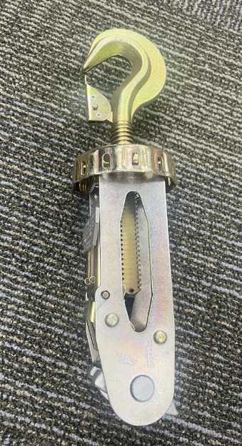
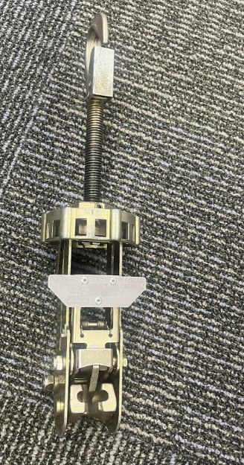

Figure 1: CGU-8/A (Left) and CGU-7/A Figure 2: Tiedown devices
Source: AFLCMC/EZFC/ATTLA Source: MIL-STD-1791D

Tiedown device | Rating (lbs) | C-130A-H | C130J | C-130J-30 | C-17 | C-5
Tiedown device | Rating (lbs) | Number available
CGU-1/B Tiedown Devices | 5,000 | 40 | 40 | 40 | 50 | 50
CGU-8/A Tiedown Devices | 10,000 | 34 | 34 | 34 | 46 | 75
CGU-7/A Tiedown Devices | 25,000 | 6 | 6 | 6 | 46 | 75
Ramp Tiedown Rings (lbs.)  Floor Tiedown Rings (lbs.) |  | 5,000 | 5,000 | 5,000 | 25,000 | 25,000
 |  | 10,000 (Floor) 25,000 (3 fore, 2aft) | 10,000 (Floor) 25,000 (2 aft) | 10,000 (Floor) 25,000 (2 aft) | 25,000 | 25,000
Table 1: Tiedown devices and respective aircraft limits¹
Source: MIL-STD-1791D
The rated capacity of a tiedown device is valid only when used in pure tension. In most cases, cargo units are secured using tiedown devices angled from their attachment points to the floor provisions. This method allows a single tiedown device to provide restraint in multiple planes, though the restraint level is reduced based on the angle of application. The combined forces applied simultaneously in each principal plane must not exceed the lower value of either the tiedown device's rated capacity or the tiedown provision's capacity. The type of tiedown device used can depend on many factors including: the weight of the item to be restrained, the strength of the aircraft floor and the required restraint force. Below is a table that showcases the different types of devices and cargo aircraft limits.

The ratings provided are the working load limits based on several engineering and safety factors, aircraft-specific requirements, safety factor calculations. There are a few reasons why performing an analysis on those devices would be useful:
- Proving that they meet existing standards
- Safety margins verification
- Failure analysis to showcase how and why they fail under different conditions
- Lifecycle analysis
- Risk and safety management
- Updating the standards
- Academic and scientific value

Analysis and testing
To perform an analysis and testing of those tiedown devices, a combination of analytical methods and physical testing may be employed. Each approach has unique insights into the device’s performance under different operational loads.

Stress Analysis:
This analysis involves calculating stress and deformation using established formulas. It serves as a baseline for understanding the device's capacity.
- Methodology: Key calculations include tensile stress (σ=P/A), shear stress (τ=V/A), elastic deformation, and thermal expansion. This analysis identifies whether stresses exceed the material's allowable limits under simplified load conditions.

- Key Assumptions: This method assumes the material is homogeneous and isotropic (uniform properties in all directions) and that loads are static (applied slowly and steadily).

- Limitations: The results are often conservative and may not be accurate for complex geometries where stress concentrations occur. It also assumes a uniform distribution of load, which may not reflect real-world scenarios.

Finite Element Analysis:
FEA is a computational method used to simulate how a device behaves under various conditions, offering a more detailed picture of its structural response.
- Methodology: A Computer-Aided Design (CAD) model of the tiedown device is created and meshed into smaller elements. By applying simulated loads and boundary conditions, the analysis predicts stress concentrations, visualizes the load distribution path, and identifies probable failure locations.
- Key Assumptions: The accuracy of an FEA model depends on assumptions about how loads are applied (e.g., concentrated at a point vs. distributed over an area), the stiffness of contact points, and the exclusion of other physical effects like thermal expansion or material wear.
- Limitations: Results are highly sensitive to the quality of the mesh; a coarse mesh can significantly misrepresent peak stresses. Convergence issues can arise in complex simulations. The model is only as accurate as the boundary conditions used to represent its real-world connections.

Tensile Testing:
This destructive testing method provides real-world data on the device's ultimate strength and failure behavior.
- Methodology: The device is installed in a calibrated tensile testing machine, and a progressively increasing load is applied until it fails.
- Expected Results: This test directly measures the Ultimate Tensile Strength (UTS), for example, a range of 15,000 to 75,000 lbs depending on the specific device as well as its yield strength and modulus of elasticity. It also reveals the actual failure mode (e.g., ductile tearing, brittle fracture).
- Limitations: Test samples may not be perfectly representative of all manufactured units. The controlled laboratory environment (temperature, humidity) may not capture real-world service conditions, and the applied strain rate can influence the measured strength.

Comparison and validation of results
By employing these three methods, we can perform a comprehensive validation of our tiedown device design. We will directly compare the predictive models against real-world data by checking if the failure loads and locations predicted by our Finite Element Analysis align with the Ultimate Tensile Strength and actual break points from the physical tensile test. Starting with Hand Analysis: Quick verification of devices that meet basic requirements. Using FEA for Optimization: Identify stress concentrations and design improvements. Validate with Testing: Confirm real-world performance and failure modes.

This process validates the accuracy of our computer simulations. Furthermore, we can compare the simple average stress from classical calculations to the localized peak stresses revealed by FEA, which allows us to understand the true impact of complex geometry and stress concentrations. When the results from our baseline calculations, detailed simulations, and physical tests all correlate, we establish a high degree of confidence in the tiedown device's safety and performance under operational loads.

Expected results
We expect to conclude with a verified load capacity for the tiedown device, allowing us to calculate its true factor of safety. A key outcome will be a validated FEA model, confirmed by physical test data, which will serve as a reliable model for evaluating future design modifications efficiently. The analysis will also pinpoint the exact failure modes and weakest points in the design, whether in a weld, connection point, or base material. Ultimately, this will lead to a final, data-driven recommendation: either a formal validation of the current design for production or a specific list of actionable improvements needed to enhance its strength and reliability.

References
- MIL-STD-1791D Distro A, https://quicksearch.dla.mil/
- MIL-STD-209K, Distro A, https://quicksearch.dla.mil/

